Subject name: **Source code management**

Subject code: **CS181**

Cluster: **Beta**

Department: **CSE**

Submitted by: Submitted to:

Aditya Sehra Dr. Monit Kapoor

2110990099

G8-A

Task 1.1

Aim: Setting up of Git Client

## Installing Git: download the Git installation program (windows, Mac or Linux) from <http://git-scm.com/downloads>.

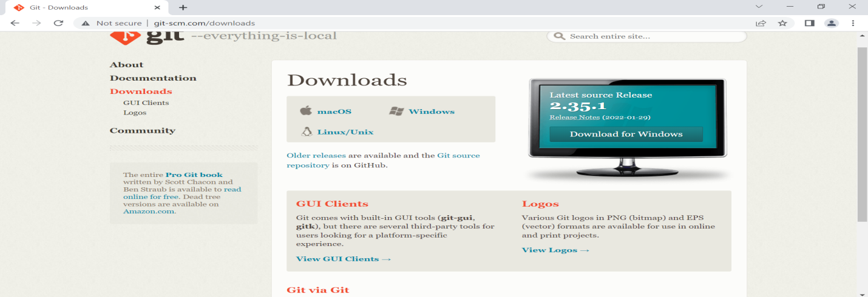

Run the installer.

While running the installer, various screens appear. You can accept the default options in most of the boxes.

Accept the general public license

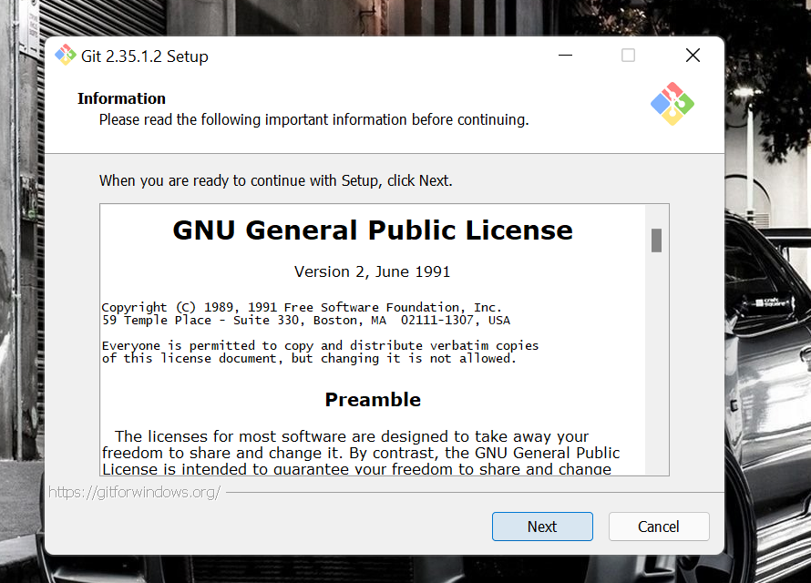

**In the Select Components screen, make sure Windows Explorer Integration is selected as shown:**

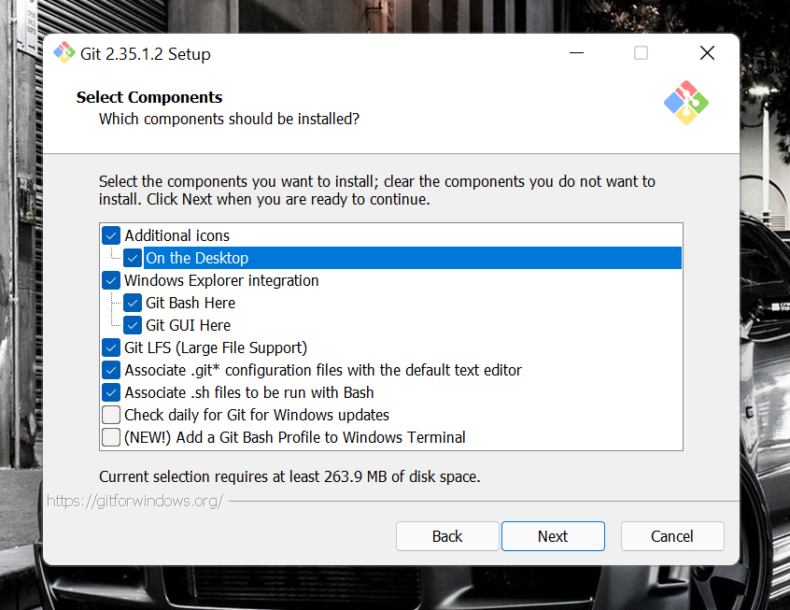

Choose the default editor to be used by Git according to your convenience.



In the Adjusting your PATH screen, all three options are acceptable:

1. **Use Git from Git Bash only**: no integration and no extra command in your command

path.

2. **Git from the command line and also from 3rd- party software**: add flexibility – you can simply run git

from a windows command prompt, Powershell or other third-party software.

3. **Use Git and optional Unix tools from the Windows Command Prompt**: this is also a

robust choice and useful if you like to use Unix like commands.

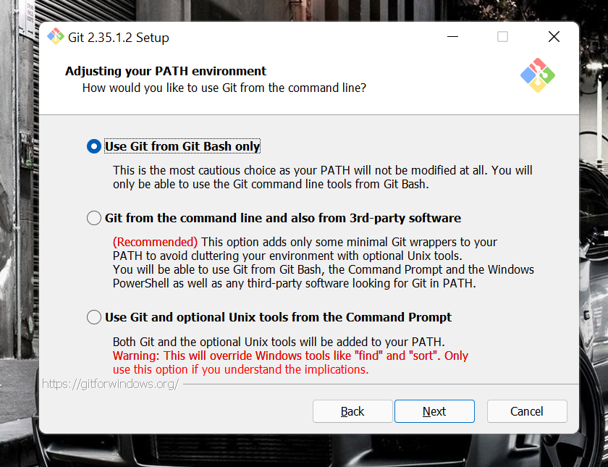

Rest all dialog box can be chosen with the default selections.

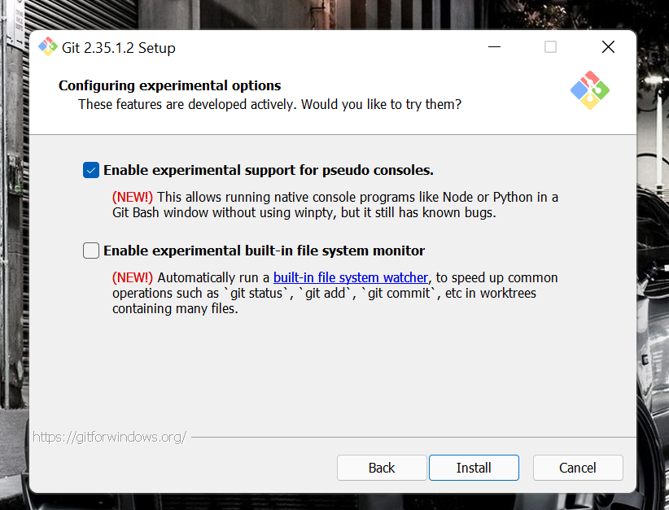

Click the install button to run the installation.

The Git bash would be successfully installed on your os.

AIM: Setting up GitHub account

The first steps in starting with GitHub are to create an account, choose a product that fits your

needs best, verify your email, set up two-factor authentication, and view your profile.

There are several types of accounts on GitHub. Every person who uses GitHub has their own

user account, which can be part of multiple organisations and teams. Your user account is

your identity on GitHub.com and represents you as an individual.

**1. Creating an account:** To sign up for an account on GitHub.com, navigate to

https://github.com/ and follow the prompts.

To keep your GitHub account secure you should use a strong and unique password.



**2. Choosing your GitHub product:** You can choose GitHub Free or GitHub Pro to get

access to different features for your personal account. You can upgrade at any time if

you are unsure at first which product you want.

**3. Verifying your email address**: To ensure you can use all the features in your GitHub plan, verify your email address after signing up for a new account. For more

information, see “Verifying your email address”.

**4. Configuring two-factor authentication:** Two-factor authentication, or 2FA, is an extra layer of security used when logging into websites or apps. We strongly urge you to

configure 2FA for safety of your account. For more information, see “About twofactor authentication."

**5. Viewing your GitHub profile and contribution graph:** Your GitHub profile tells people the story of your work through the repositories and gists you’ve pinned, the

organisation memberships you’ve chosen to publicize, the contributions you’ve made,

and the projects you’ve created.

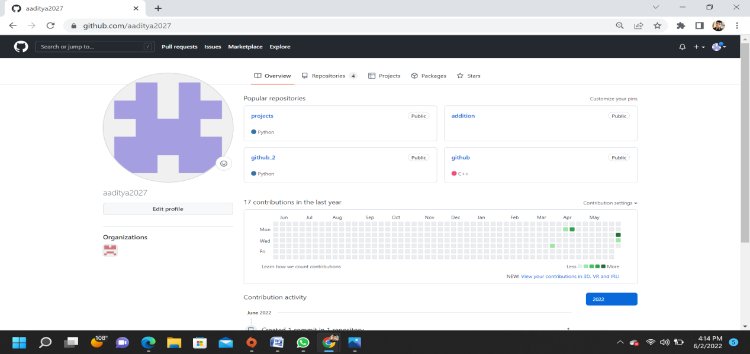v

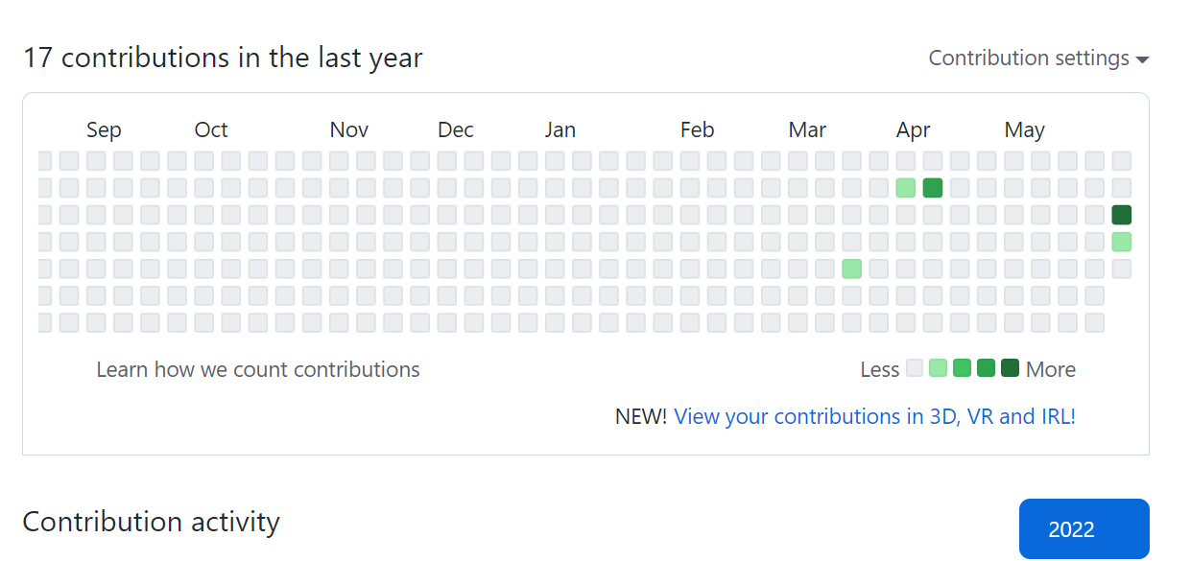

Configuration of Git

You can configure your Git by typing: -

1. Set your username: git config --global user.name "Your Name"
2. Set your email address: git config --global user.email "Your Email

The page looks like as: -

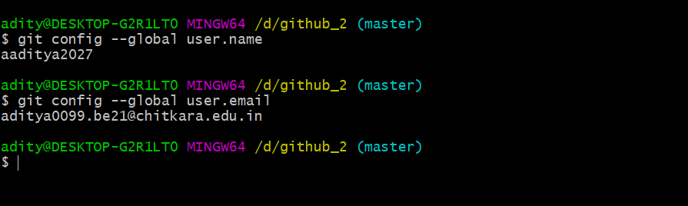

Program to generate logs

**Program to Generate logs:**

**Advantage of version control systems like git is that it can record changes.**

**‘Git log’ command is used to display all these changes that were made by the user in the repository. Log is a record of all the previous commits.**

**To understand Logs we need to get familiar with all the commands that are used in making changes to a repository.**

1. **Repository:**A repository is a directory that contains all the project-related data.

1. **Git init:** The git init command is used to create a new blank repository.
2. **Git status:** We can list all the untracked, modified and deleted files using the git status command.
3. **Git add:** Adds all the untracked and modified files to the staging area.
4. **Git commit:** Git commit finalizes the changes in the repository. Every commit is saved in the branch you are working in and can be used to revert back to older versions of the project.

Git repository

**Step1: GIT INIT**

**Initializing a new repository, You Can do it by typing: -**

1. **git init**

**The page looks like as: -**

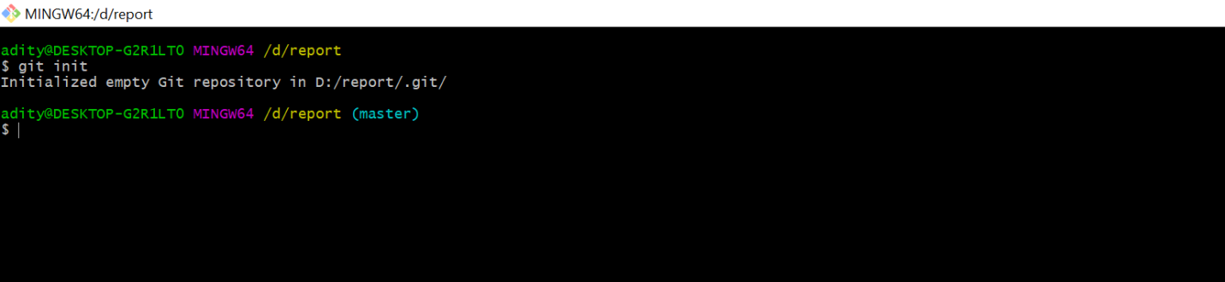

**Step2: GIT ADD**

**The git add command adds a change in the working directory to the staging area.**

**You Can do it by typing: -**

1. **git add**
2. **git add (current file name)**

**The page looks like as: -**

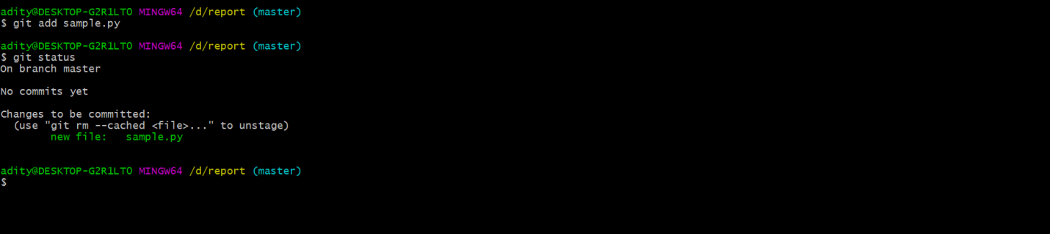

**Step3: GIT COMMIT**

**The "commit" command is used to save your changes to the local repository.**

**You Can do it by typing: -**

1. **git commit -m”any text”**

**The page looks like as: -**



**Step4: GIT LOG**

**Git log will show all the commits made by the author with their time.**

**After every commit the checksum value (written In yellow color) of the folder changes.**

**Checksum is used to verify that the data in that file has not been tampered with or manipulated, possibly by a malicious entity.**

**You Can do it by typing: -**

1. **git log**

**The page looks like as: -**

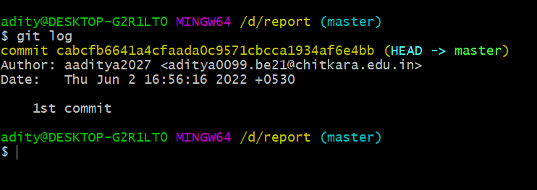

**Step6: Create and Visualize Branches**

**A branch in Git is simply a lightweight movable pointer to one of these commits. The default branch name in Git is master.**

Create and visualize branches

**Step1: CHECKING UP THE BRANCHES**

**You can check which branch you are working in by using the command**

**1.’git branch’.**

**The default branch is always the master branch.**

**The page looks like: -**

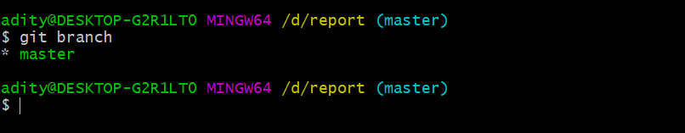

**Step2: CHANGING BRANCHES**

**To switch to the other branch**

**You Can do it by typing: -**

1. **git checkout (BRANCH NAME)**

**The page looks like as: -**

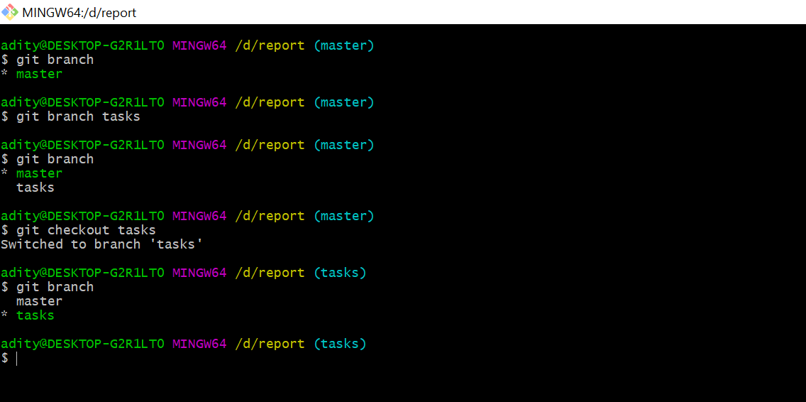

**Step3: GIT MERGING**

**Now you can merge two branches by command.**

1. **git merge (BRANCH NAME)**

**If you want to merge a new branch in master branch you need to first checkout into the master branch and then run the command.**

**The page looks like as: -**

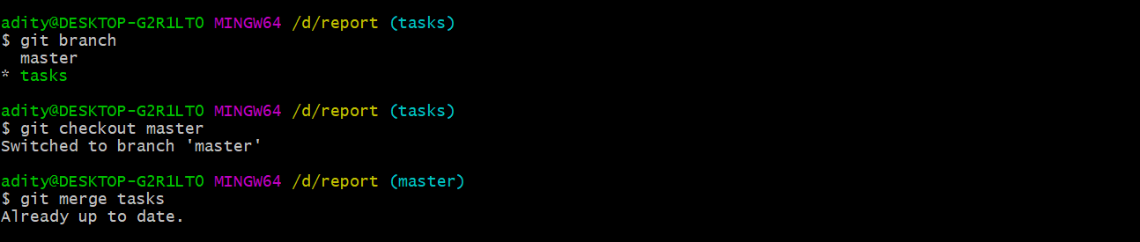

Git lifestyle description

**There are three stages for git lifecycle:**

1. **Working directory**
2. **Staging area**
3. **Git repository**

**Working Directory:**

**The working directory is the folder in your local computer where the project files and folders are stored.**

**The local directory is created by the command ‘git init’ which creates a ‘.git’ named folder which is used to track the files in the directory.**

**‘.git folder’ is generally hidden but can be tracked enabling hidden files.**

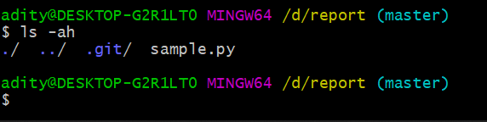

**Staging area:**

**The staging area has those files which are supposed to go to the next commit. Only those files which are needed to go to the next commit stay in the staging area.**

**You can shift the files to the git repository by using the command**

**‘git add --a’.**

**Git repository:**

**Now since we have all the files that are to be tracked and are ready in the staging area, we are ready to commit our files using the git commitcommand. Commit helps us in keeping the track of the metadata of the files in our staging area. We specify every commit with a message which tells what the commit is about.**

**You can commit files by using command ‘git commit -m “message”’**

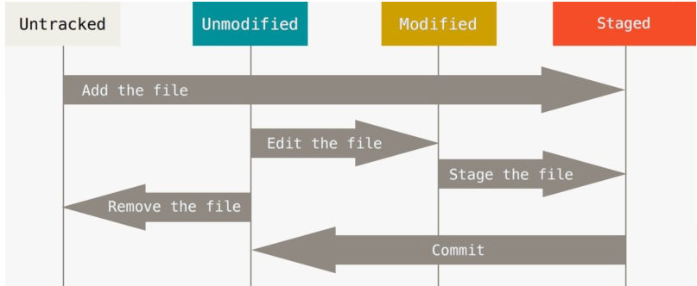

Uploading data on GitHub

**1) CREATING REPOSITORY IN GITHUB**

**The page looks like : -**

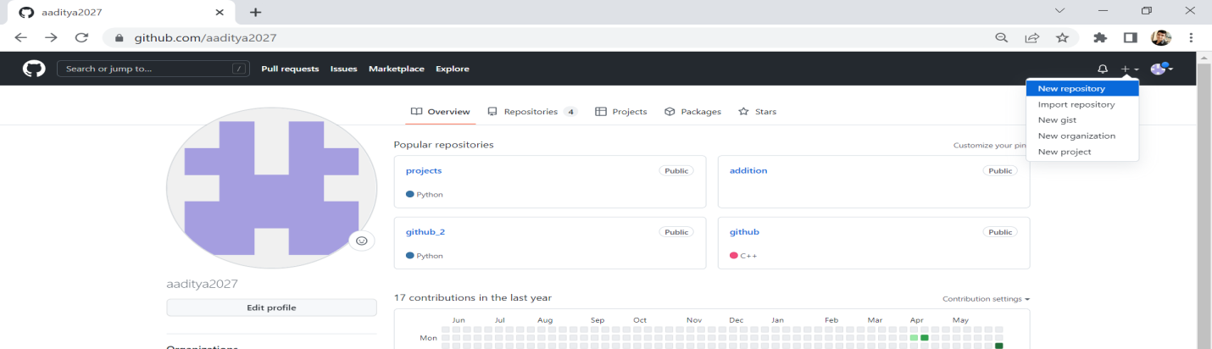

**By clicking on new you are able to make a new repository.**

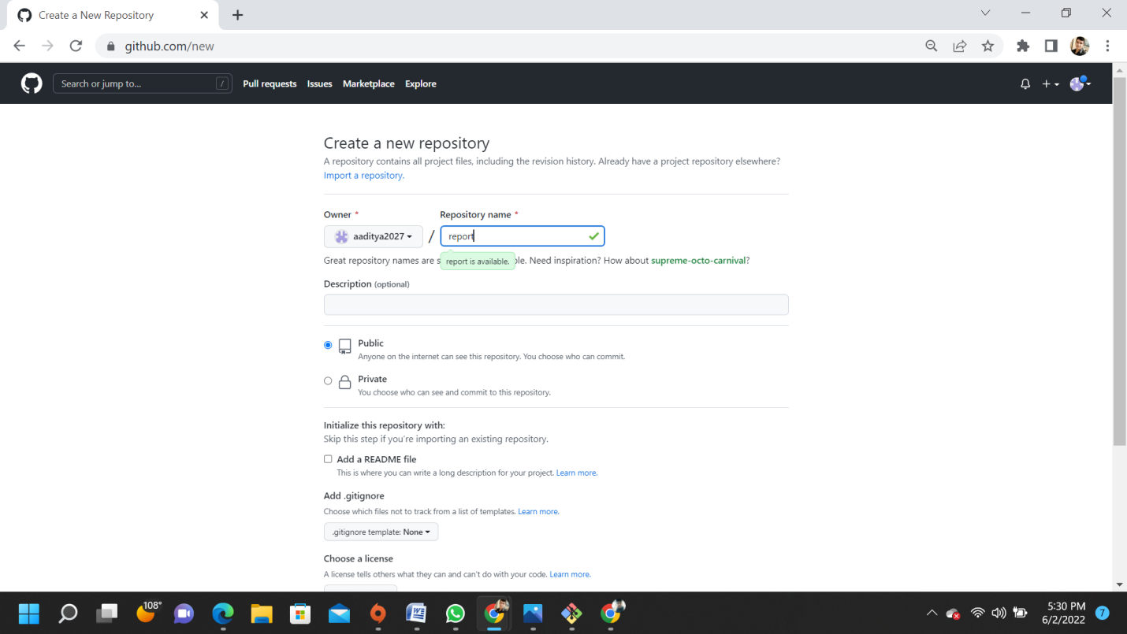

**Write the repository name and click on create repository.**

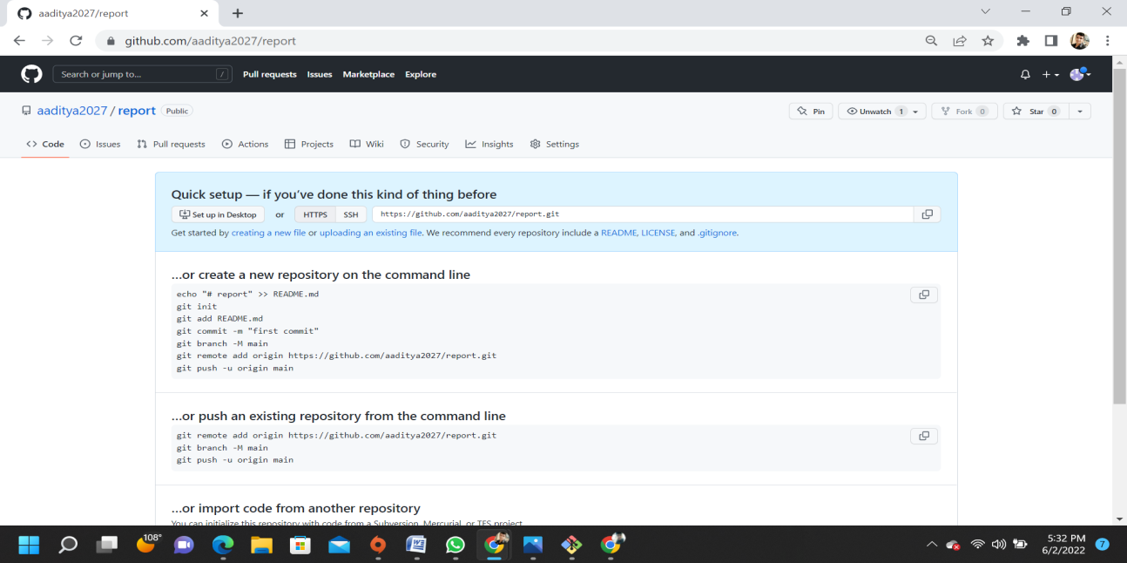

**Your GITHUB Repository has been created.**

**2) Uploading file from command line**

1. **Type git add ‘file name’:** adds file into your repo in the machine.
2. **By typing git commit –m “(**message you wanna display**)”** a commit in initiated with the message.
3. **Type git remote add origin ‘**link of the repo on net**’:** adds the link of the cloud where the repo from the machine has to be sent.

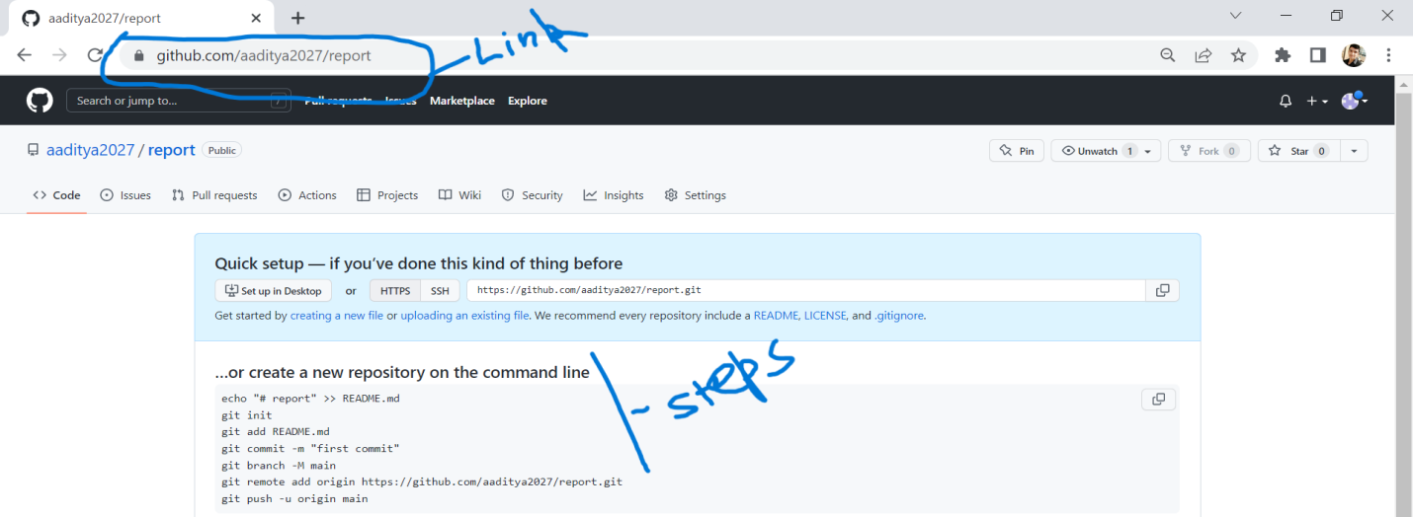

1. **Git push –u origin master: pushes the repo to the cloud in the branch.**

**The steps look like:-**

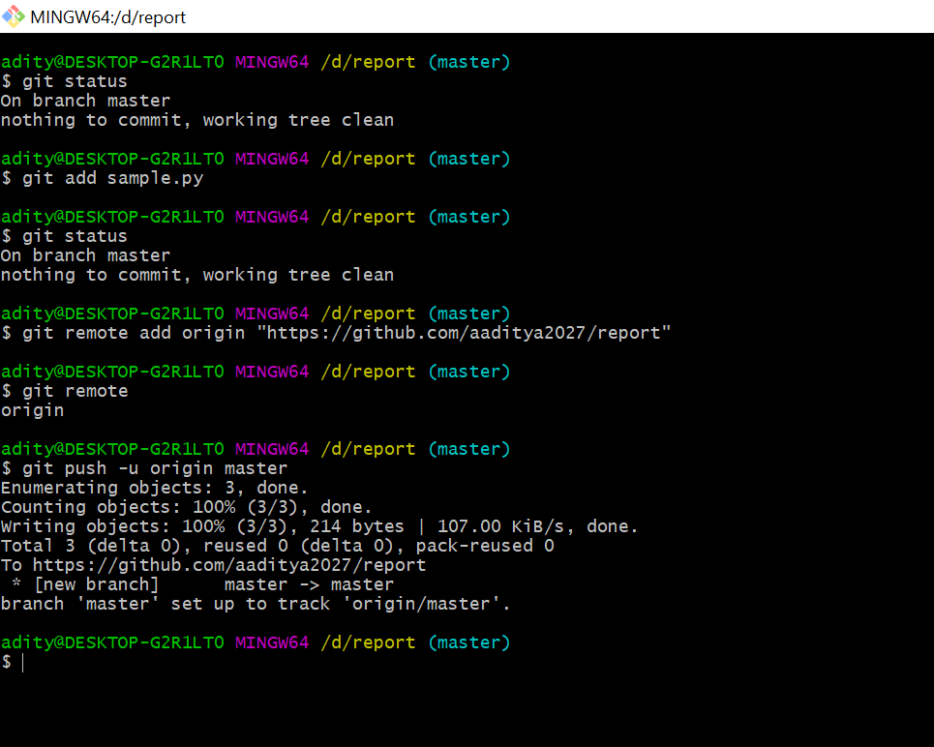

The files are uploaded in the repo.

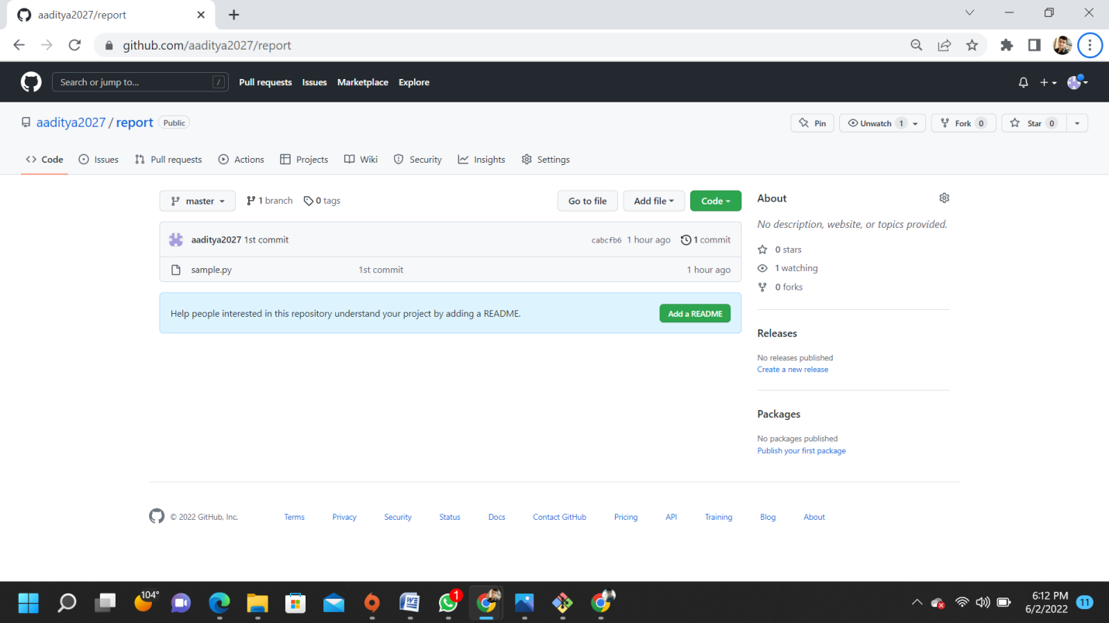

Task 1.2

AIM: Adding collaborators on Github repository

In GitHub, We can invite other GitHub users to become collaborators to our private repositories (which expires after 7 days if not accepted, restoring any unclaimed licenses).

Being a collaborator, of a personal repository you can pull (read) the contents of the repository and push (write) changes to the repository.

You can add unlimited collaborators on public and private repositories (with some per day limit restrictions). But, in a private repository, the owner of the repo can only grant write-access to the collaborators, and they can't have the read-only access.

GitHub also restricts the number of collaborators we can invite within a period of 24 hours. If we exceed the limit, then either we have to wait for 24-hours or we can also create an organization to collaborate with more people.

Actions that can be Performed By Collaborators

Collaborators can perform a number of actions into someone else's personal repositories, they have gained access to.

Some of them are,

• Create, merge, and close pull requests in the repository

• Publish, view, install the packages

• Fork the repositories

• Make the changes on the repositories as suggested by the Pull requests.

• Mark issues or pull requests as duplicate

• Create, edit, and delete any comments on commits, pull requests, and issues in the repository

• Removing themselves as collaborators on the repositories.

• Manage releases in the repositories.

**1.Add Collaborators on Github Repo :-**

**1.Ask for the username of the person you're inviting as a collaborator.**

**2.On GitHub.com, navigate to the main page of the repository.**

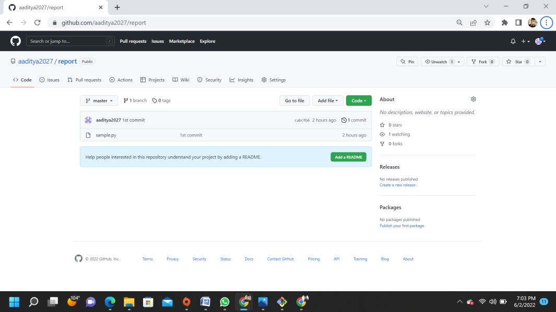

**3.Under our repository name, click Settings**

**4.In the "Access" section of the sidebar, click Collaborators & teams.**

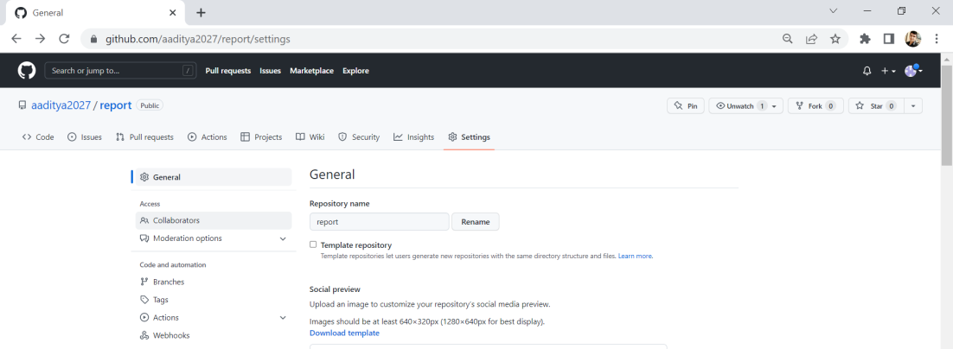

1. **Click Invite a collaborator after confirming your identity.**
2. **Search the user by his username or email.**

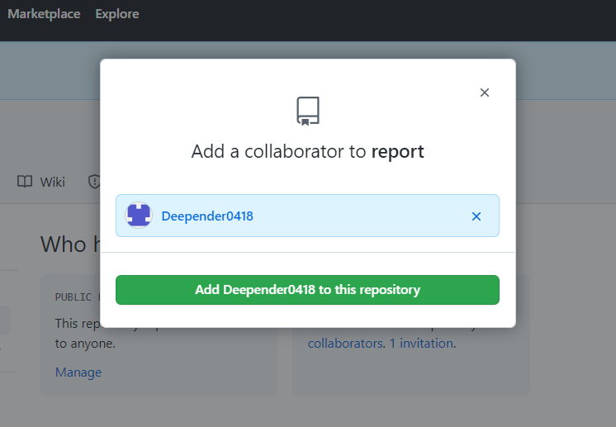

1. **Click on add the user.**

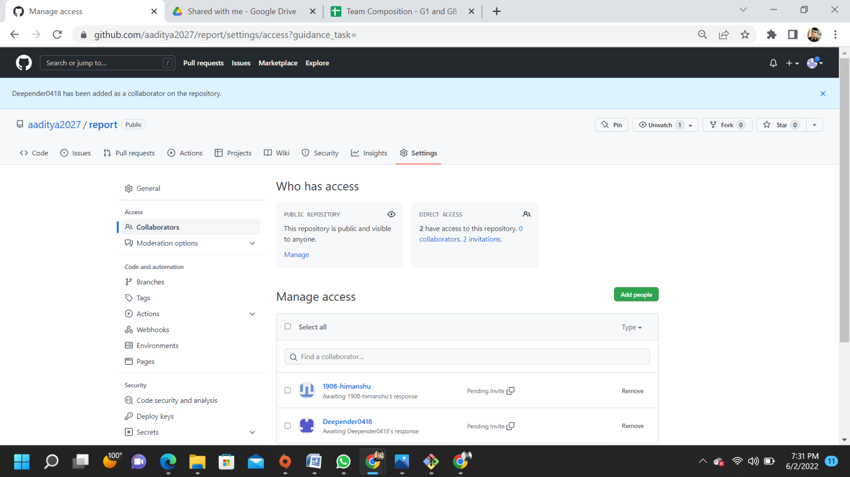

**The users will be added as the collaborators, after they accept the invite.**

1. **After sending the request for collaboration to that person whom we wanted as our collaborator for our project will get a email from the Team leader (by GitHub). He/she has to open its Email to view the invitation.**

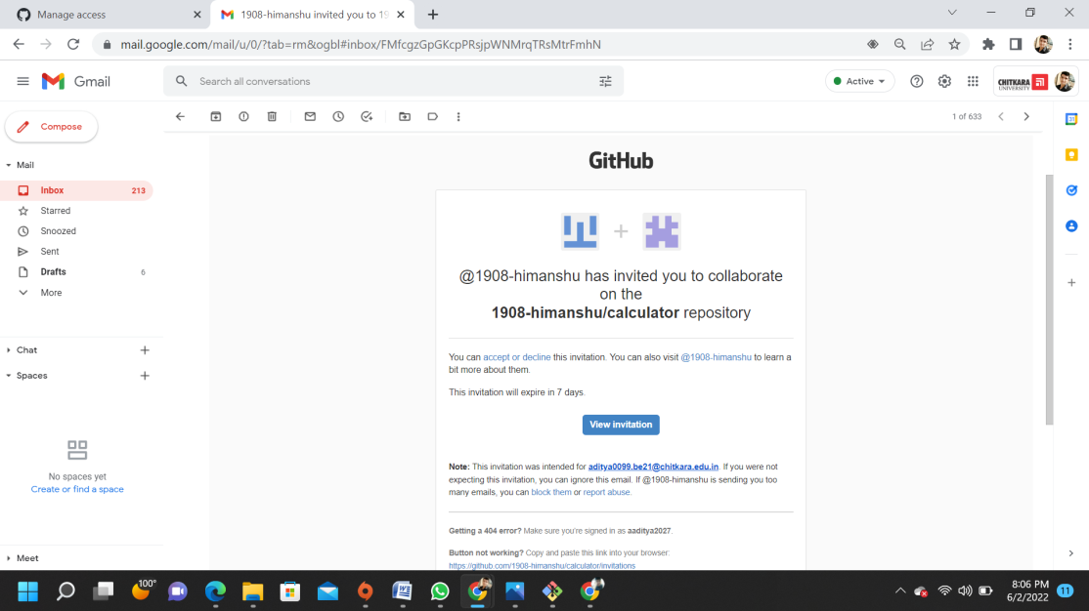

1. **After Clicking the View invitation, He/she will be redirected to the GitHub Page for accepting the invitation sent by the team leader.**

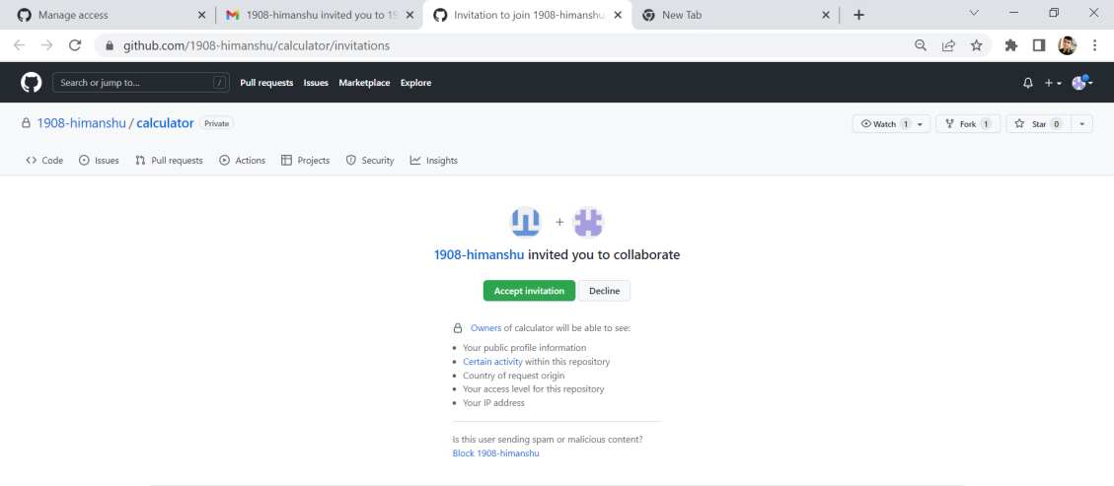

1. **We are done adding a single collaborator. Now, they will get a mail regarding invitation to your repository. Once they accept, they will have collaborator access to your repository. Till then it will be in pending invitation state.**

**You can also add more collaborator and delete the existing one as depicted below.**

**Removing collaborator permissions from a person contributing to a repository Similar to the above steps,**

**go to Your Repository -> Settings -> Manage Access -> Remove (on the right side of collaborator username).**

Aim: fork and commit

A fork is a copy of a repository. This is useful when you want to contribute to someone else's project or start your own project based on theirs. fork is not a command in Git, but something offered in GitHub and other repository hosts.

* + - 1. We can see the fork option at the top right corner of a repository page. By clicking on that, the forking process will start. It will take a while to make a copy of the project for other users. After the forking completed, a copy of the repository will be copied to your GitHub account. It will not affect the original repository.

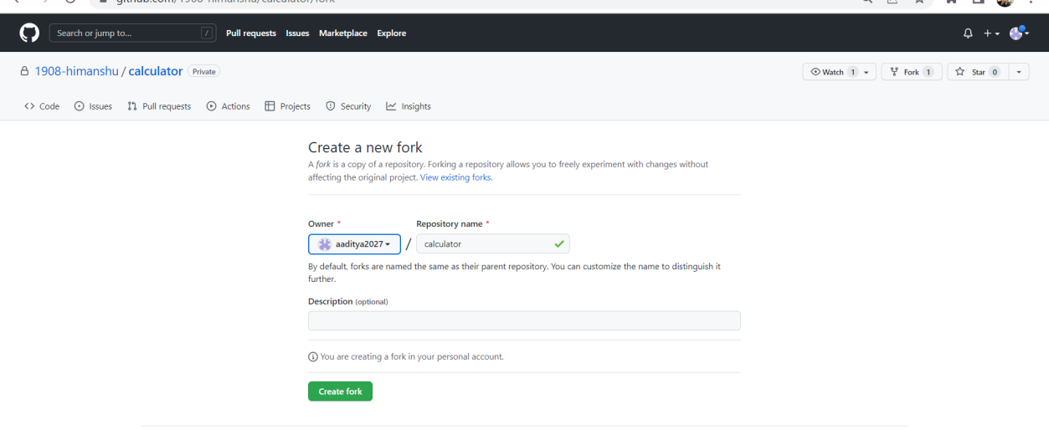

* + - 1. The fork copy will look like as follows and we can add commits to it.



* + - 1. We can freely make changes and then create a pull request for the main project. The owner of the project will see your suggestion and decide whether they want to merge the changes or not

Aim: Merge and resolve conflicts created due town activity and collaborator’s activity

# Merging Branches

Once you’ve completed work on your branch, it is time to merge it into the main branch.

Merging takes your branch changes and implements them into the main branch.

**In real world, when we merge branches, we will run into conflicts quite often. Conflict happens because of the following reasons −**

• When the same line of code is changed in different ways in two branches.

• A given file is changed in one branch but deleted in another branch.

• Same file is added twice in two different branches but the content of the file is different.

In these cases, git will stop the merge process as it cannot figure out how to merge the changes.

In such scenarios we need to intervene manually and instruct how to proceed with the merging process.

Procedure:

1. Create a repository with initial commit with the conflict_1.txt file.

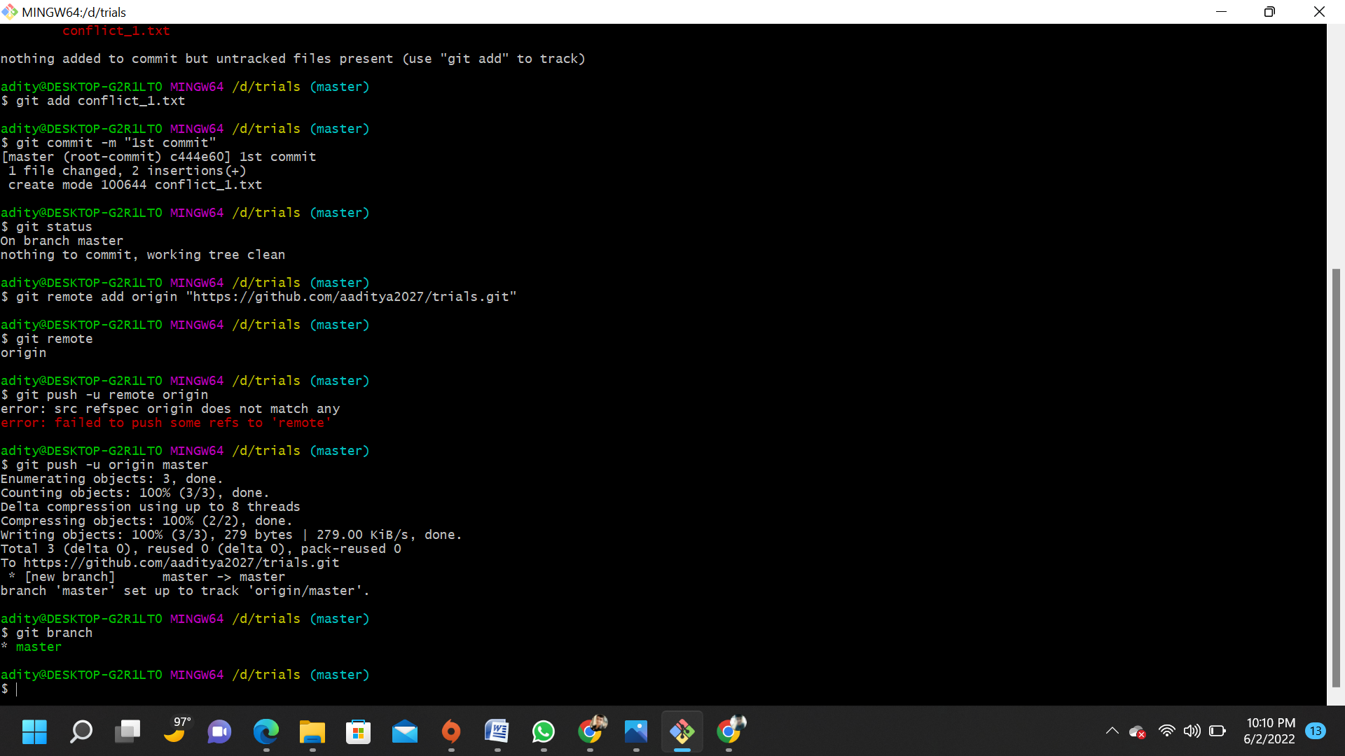

1. Create a new branch feature. Switch to the feature branch and create a new commit by editing the second line in the conflict_1.txt file.

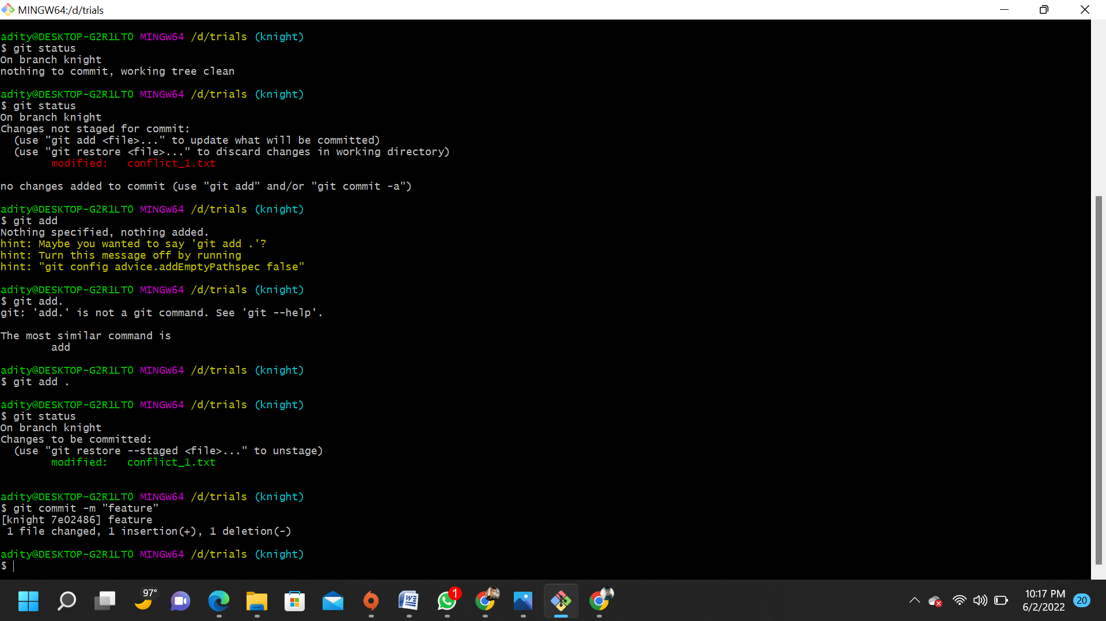

1. Now switch to the master branch and perform a new commit by adding a new line to conflict_1.txt.

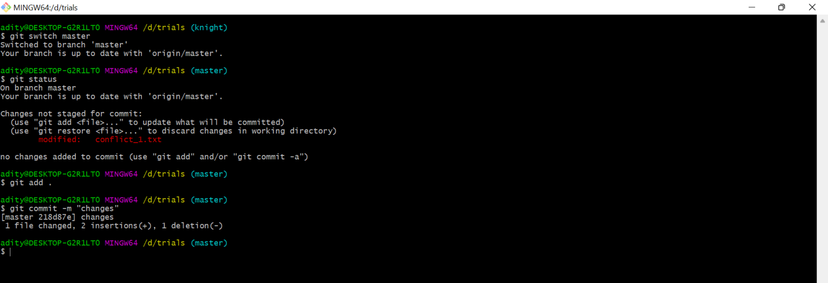

Git Reset :-

Git reset is a powerful command that is used to undo local changes to the state of a Git repo. Git reset operates on "The Three Trees of Git". These trees are the Commit History (HEAD), the Staging Index, and the Working Directory.

The easiest way to undo the last Git commit is to execute the “git reset” command with the “–soft” option that will preserve changes done to your files.

Git reset --hard , which will completely destroy any changes and remove them from the local directory.

reset is the command we use when we want to move the repository back to a previous commit, discarding any changes made after that commit.

1. We need to find the point we want to return to. To do that, we need to go through the log.

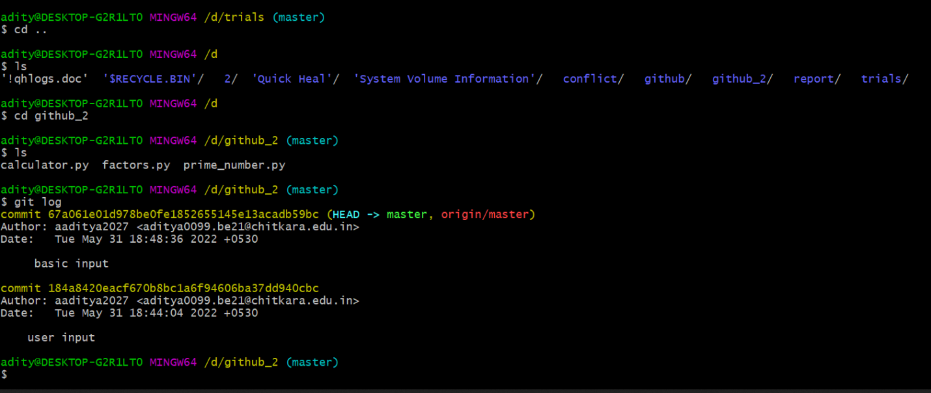

1. You can reset your commit back to the log where you wish to by using git reset commithash(first 7 characters of the commit found in the log).

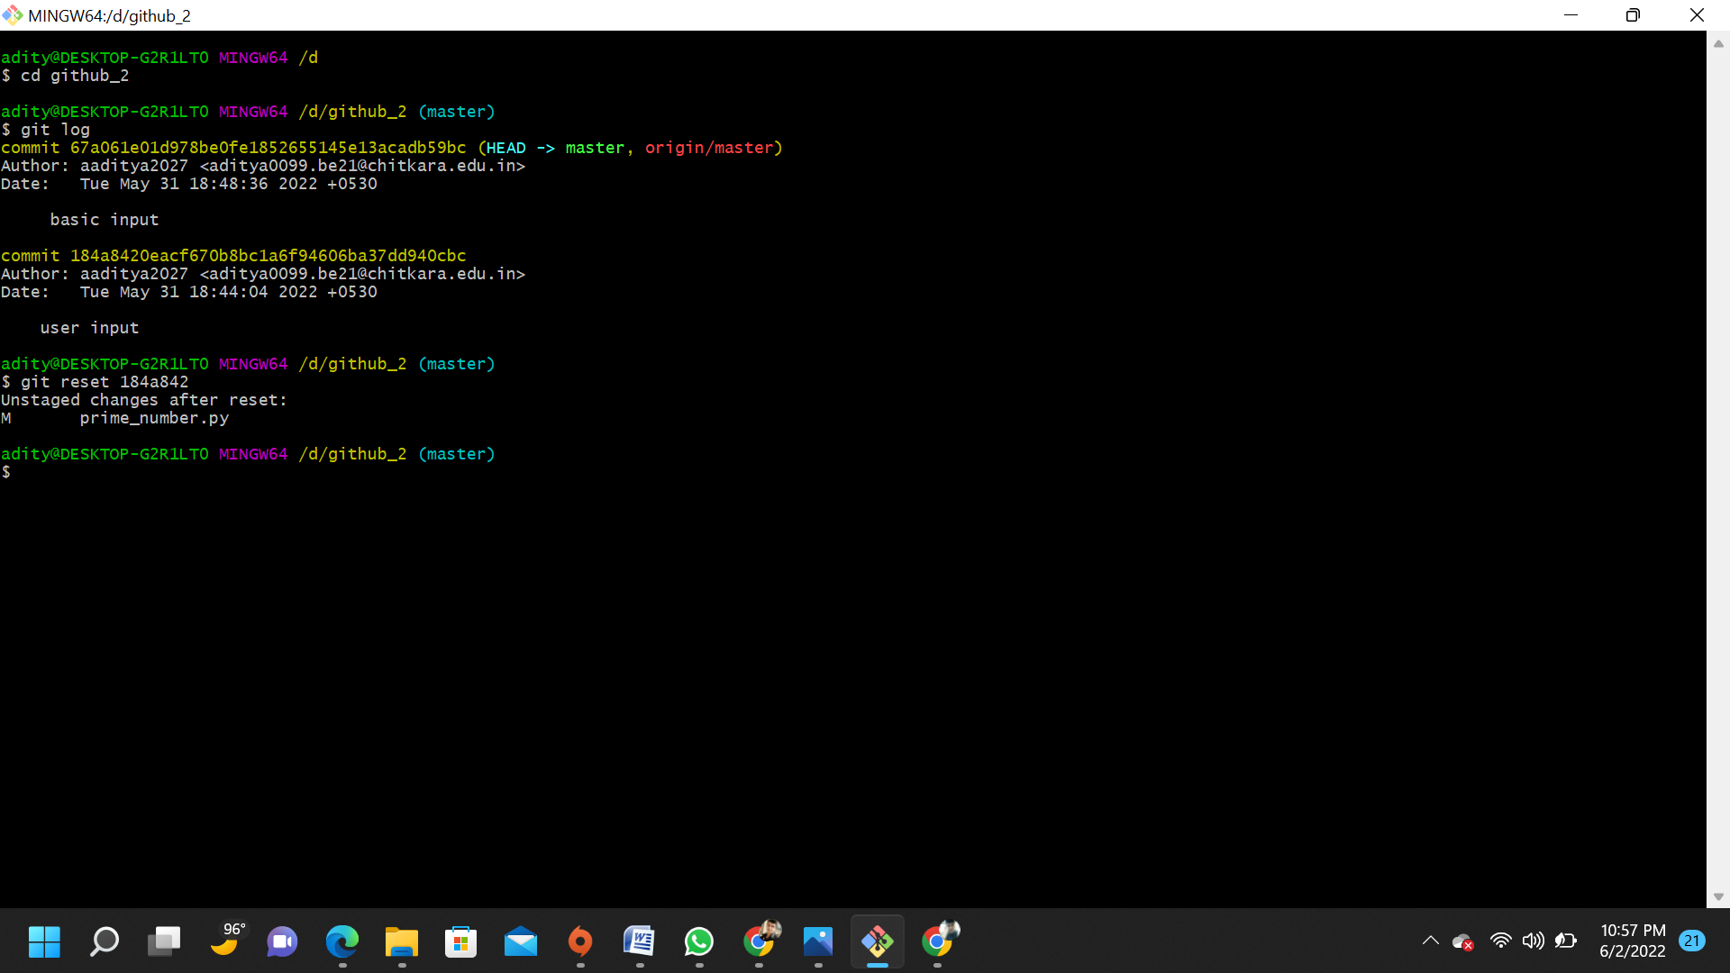

See the log to notice the change after opting for reset.

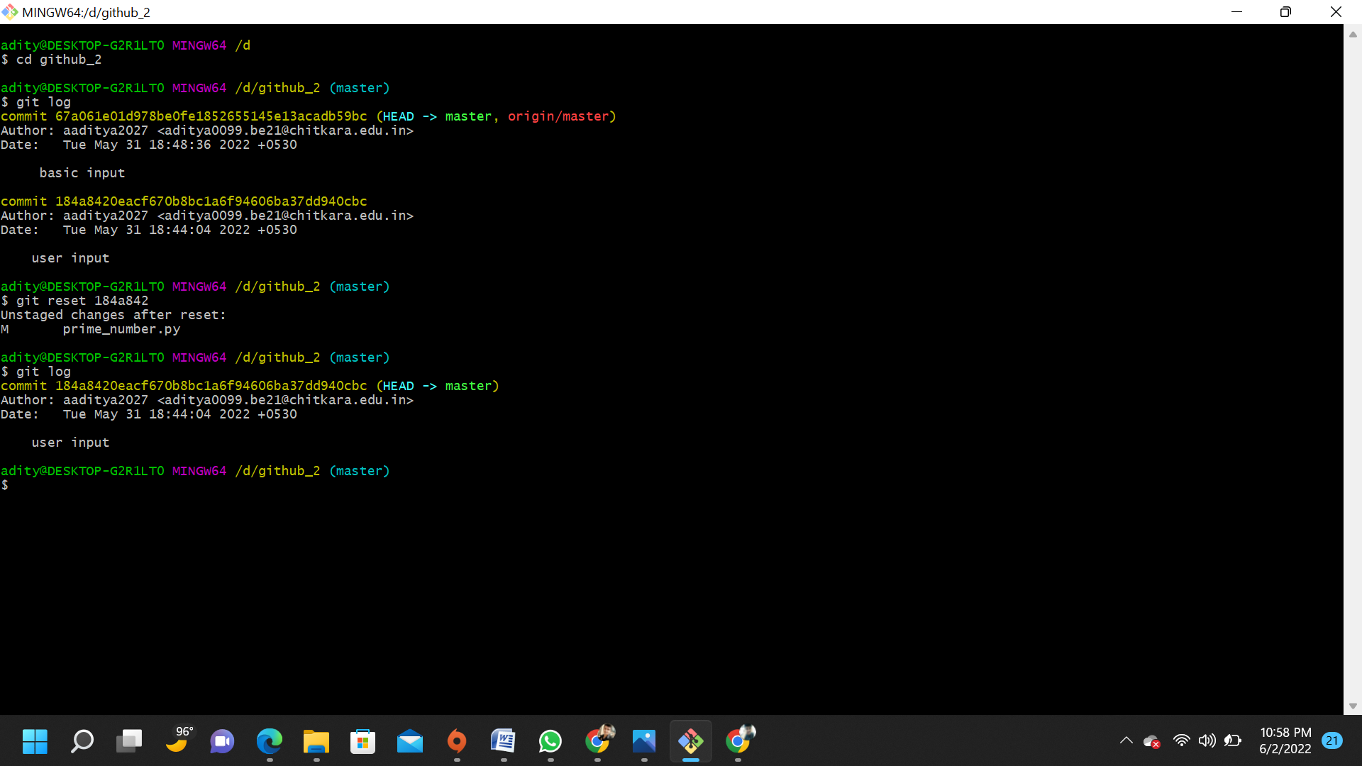.

Task 2

Create a distributed repository and add members to the team

# Now let’s discuss how to work with the distributed approach.

# While in centralized approach, everyone on team cloned the

# single central repository, here in distributed approach everyone

# clones ‘a copy of the source repository’ also known as ‘forking’.

# In this approach, all the collaborators will ‘fork’ the source repo.

# Upon forking ever member gets their own copy of the source

# repository in their GitHub account. Collaborators can then go

# ahead and clone their ‘forked repository’ on their local

# machines.

Adding members to the team

1. Create a new repository

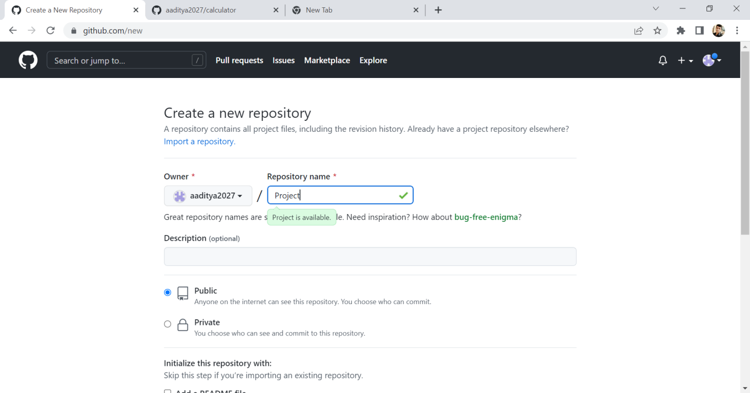

2) Add Collaborators on your team

**1.Ask for the username of the person you're inviting as a member.**

**2.On GitHub.com, navigate to the main page of the repository.**



**3.Under our repository name, click Settings**

**4.In the "Access" section of the sidebar, click Collaborators & teams.**



1. **Click Invite a collaborator after confirming your identity.**
2. **Search the user by his username or email.**



1. **Click on add the user.**



**The users will be added as the collaborators, after they accept the invite.**

Open and close a pull request

click on the Fork button in the top-right corner.

The copy includes all the code, branches, and commits

from the original repo.

2. Clone the repository and Create a new branch .

3. Now you can make changes to the code.

4. Once you push the changes to your repo, the Compare & pull request  button will appear in GitHub.

To pull request github repository and raise pull request by clicking on contribute button as u can see below:

